press release

World Premiere at Berlinale: Alexander Zolotukhin’s feature film, Brother in Every Inch

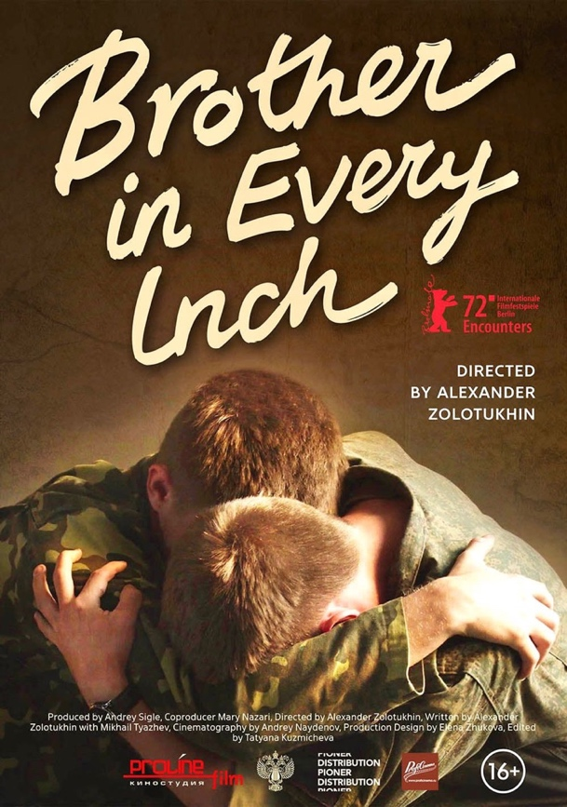
The 72nd Berlin International Film Festival will take place from February 10th until the 16th. The feature film BROTHER IN EVERY INCH by Russian director Alexander Zolotukhin will celebrate its world premiere in the section Encounters.
This is the story of the painful separation of twin brothers, whose deep and sincere affection for each other hinders them from attaining their shared dream - becoming air force pilots.
One of the most famous Russian filmmakers, Alexander Sokurov, was the creative consultant for this project. He has a fair claim at being Russia’s most distinguished living filmmaker. His most significant works include Russian Ark (2002), Father and Son (2003), and Faust (2011), which was honored with the Golden Lion, the highest prize for the best film at the Venice Film Festival.

Alexander Zolotukhin completed Alexander Sokurov’s directing course at the University of Kabardino-Balkaria. The international premiere of Alexander Zolotukhin's debut feature film A Russian Youth took place at the 69th Berlin International Film Festival.

Brother in Every Inch shows how two brothers on the way to their goal – training to be military pilots – have to mature and learn to make decisions on their own.

“People who have dedicated their lives to their calling are brave, intelligent, determined individuals. They sacrifice their peace of mind and prosperity for their dreams. This is a special breed of people, which is most clearly noticeable in the military, in the personalities of those young guys who have chosen a military profession filled with romantic notions. As the son of a military pilot, I know what I am talking about. You don’t become an air cadet by accident. Flying is a cadet’s calling, their childhood dream. Once they have enrolled, these young men enter a period of their lives where they have already taken the first step toward realizing their dream. This is a special kind of brotherly bond that lasts for a lifetime. It’s always interesting to observe fundamentally good people. What are their personalities like? How do they cope with setbacks? What do they talk about? What do they think about? Screenwriters rarely tackle this sort of character because it is hard to find any dramatic conflict in their relationships. But it is often these people who face the most intense internal struggles, while the contradictions of their natural inclinations are deeply buried. Our aim is to examine how people like this behave in difficult, sometimes life-threatening circumstances. We often see people who are close to each other experience tragedies stemming from hatred, jealousy, and resentment. So how dramatic might the relationship be between two brothers who care deeply for each other and are both training for a dangerous career in the military?” said Alexander Zolotukhin.

Twin brothers Andrey and Mitya, the main characters of the film, are cadets at the same military flying school. Despite their contrasting personalities (one of the brothers is strong and stubborn, and the other is calm and level-headed), the brothers have a strong bond.

The brothers are very worried about each other before each flight, and this affects their performance, so Andrey and Mitya are in danger of falling short of their dreams. They understand that they need to try to distance themselves from each other, but it turns out to be incredibly difficult for the twin brothers to do this.

“Before filming, we underwent serious training, including practice flights, stayed at a military base, disassembled and worked out every scene with director Alexander Zolotukhin. He helped and supported us at every stage, and also spoke with Alexander Sokurov, who created the right atmosphere before we went on set. This is our first film, and it will always be the most significant one in our careers,” said actors Nikolay Zhuravlev and Sergey Zhuravlev.
Cinematography by Andrey Naydenov, who worked on films such as Dear Comrades! (directed by Andrei Konchalovsky) and Euphoria (directed by Ivan Vyrypaev) and many others.

The film will use Russian and European classical music – gentle and melodic, but also passionate and dynamic – to accentuate the main characters’ relationship and lifestyle.

Encounters appeared at the Berlin International Film Festival in 2020. Encounters is a platform aiming to foster aesthetically and structurally daring works from independent, innovative filmmakers. Its goal is to support new perspectives in cinema and to give more room to diverse narrative and documentary forms in the official selection.

BROTHER IN EVERY INCH (16+)
Year of production: 2022
Genre: Drama
Duration (in minutes): 80.
Production: Proline Film
Country of production: Russia
Produced by Andrey Sigle, Mary Nazari
Directed by Alexander Zolotukhin
Creative consultant: Alexander Sokurov
Screenplay written by Alexander Zolotukhin (in partnership with Mikhail Tyazhev)
Cinematography: Andrey Naydenov
Production design: Elena Zhukova
Edited by Tatyana Kuzmicheva
Main cast: Sergey Zhuravlev, Nikolay Zhuravlev, Mikhail Klabukov, Alexandra Shevyreva, Egor Kutushov.

Supported by the Ministry of Culture of the Russian Federation, the Ministry of Defense of the Russian Federation.

SYNOPSIS
Our days. Two brothers training to be military pilots. They have a strong bond and are always together. The two of them have one dream - to conquer the sky. But their close relationship hampers their training, and the brothers begin to make mistakes in the air. They find themselves facing the choice of continuing to live one life for two or letting each other go. The choice is complicated by the fact that the brothers are twins and it is extremely painful to be apart.

Poster: https://disk.yandex.ru/i/cWAZK5PnP_qE4w
Photos from the set: https://disk.yandex.ru/d/3-w2v7OVzUgklQ

Director
Alexander Zolotukhin
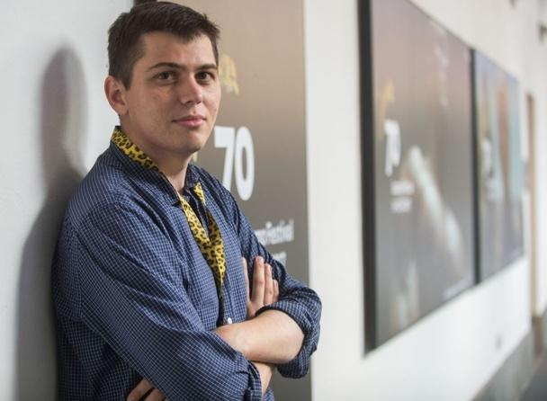
Alexander Zolotukhin was born on September 7th, 1988 in the city of Zaporozhye in the Ukrainian SSR.
He is familiar with the air force, as he was born in the family of a military pilot and spent his whole childhood "near the runway.”
Alexander completed Alexander Sokurov’s directing course at the University of Kabardino-Balkaria. The international premiere of Alexander Zolotukhin's debut feature film A Russian Youth took place at the 69th Berlin Film Festival.
The film was first shown to Russian viewers at the 30th Kinotaur, where it was awarded the Diploma of the Guild of Russian Film Experts and Critics. A Russian Youth was named Best Film in the Forward Future program at the International Film Festival in Beijing. The film won three foreign film awards at the Fajr Film Festival in Tehran: the Grand Prix for Best Debut, Circle Award 2019 for Best Film, and Film Critics’ Award.

Alexander Zolotukhin’s Movies
2022 Brother in Every Inch
2019 A Russian Youth
2017 My Friend 's Life (short film)
2015 Forests of Babylon (short film)

For more information about the film and press materials please contact us.
PR-Agency ProfiCinema
e-mail: pr@proficinema

